**Practice Problem from a previous semester:**

Consider the following scenario and then answer the corresponding questions.

ABC Travel and Tourism specializes in providing tourist packages to customers across the globe and the company has decided to develop an in-house software system that will help customers search for travel destinations based on popularity, budget, visa restrictions, government policies and attractive climatic conditions. Customers will also be able to book their air tickets, hotel and transportation (rental car, public transportation, cab services) through this system. Prior to the booking, the system will allow users to check for their visa eligibility to travel to destinations outside of their country of citizenship. Users will also be able to review and rate destinations or hotels using the system. The company also offers pre-set packages and if a customer decides to go with a specific package, they will be asked to provide the dates for their travel. The system will find an airline reservation, hotel/ transportation choices and create an itinerary for the customer. Customers will not be allowed to customize the pre-set packages.

Once the booking is done, the system should send a notification to the users on the purchase confirmation within 2 hours. Cancellations will incur a 25% penalty, if users are “Gold” members. In all other cases, the reservations will be non-refundable. Customers can pay using their credit cards or Paypal.

I am providing few possible solutions. This is a subjective exercise and the solution depends on the analyst and designer. Your approach should be closer to either of these.

Solution 1:

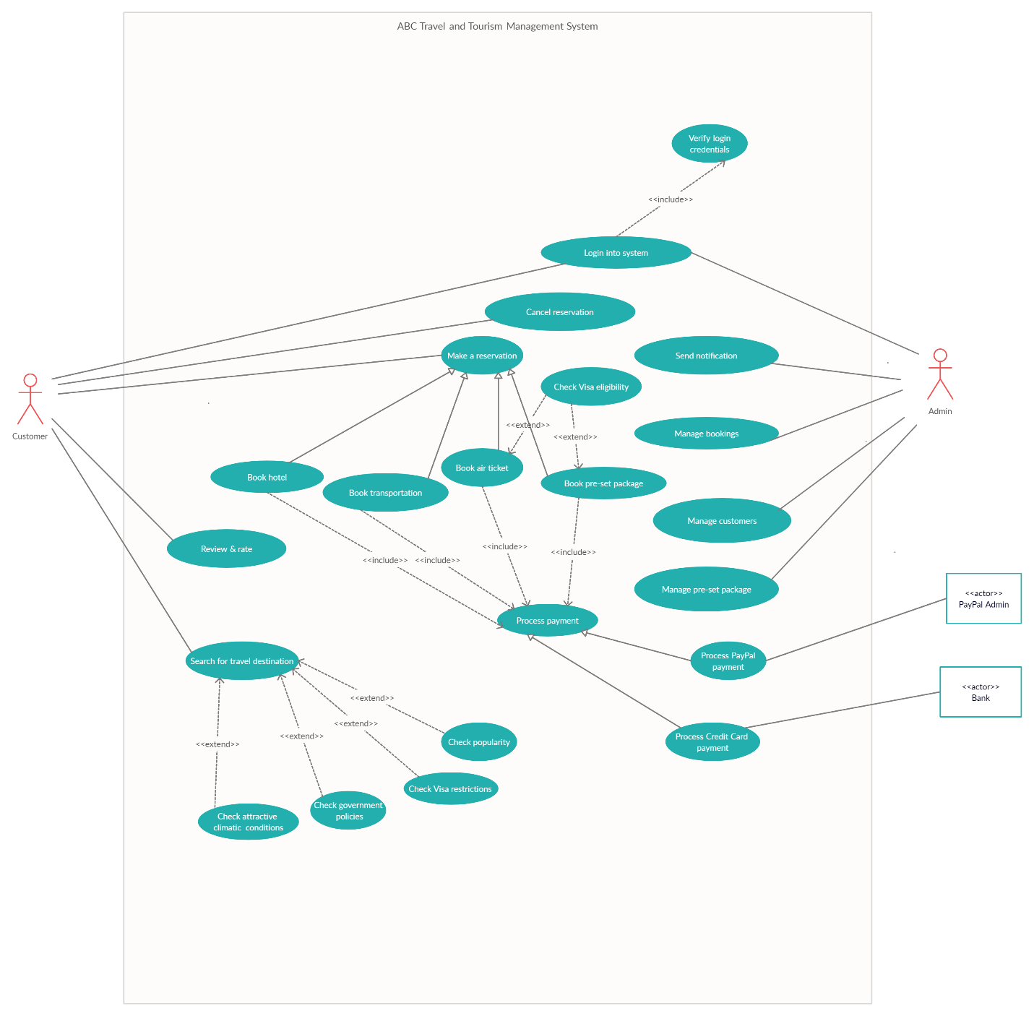

|  |  |
| --- | --- |
| **Use Case Name:** | Make a reservation |
| **Primary Actor:** | Customer |
| **Brief Description:** | Customer searches or browses through the flights, hotels and/or transportation (cabs, rental cars, or public transport) options. He/She checks accommodations/availabilities, makes payment, and then makes a reservation. |
| **Trigger:** | Customer wants to make a reservation and initiates booking |
| **Normal flow of events:** | 1. When the customer logs into the system, they select “make a reservation” option. 2. System will prompt relevant interface with necessary options. It will include – “book air ticket”, “book hotel”, “book transportation”, and “book pre-set package” options. 3. When the customer selects any of the above options, following steps are to be followed for each of them accordingly: - 4. Book air ticket 5. Customer requests a reservation 6. Customer selects the desired flight, date of travel, seat, class (business/economy) 7. System prompts with available option (an offer is made) 8. Customer agrees to proceed with the offer 9. Customer proceeds with the payment option 10. System processes the payment 11. System creates a reservation and gives it an identifier 12. System gives the customer a confirmation of the reservation with the identifier created 13. Book hotel 14. Customer requests a reservation 15. Customer selects the desired hotel, check-in date, check-out date, type of room 16. System prompts with available option (an offer is made) 17. Customer agrees to proceed with the offer 18. Customer proceeds with the payment option 19. System processes the payment 20. System creates a reservation and gives it an identifier 21. System gives the customer a confirmation of the reservation with the identifier created 22. Book transportation 23. Customer requests a reservation 24. Customer selects the desired transportation (such as cab, public transport, rental car), start time and date, end time and date 25. System prompts with available option (an offer is made) 26. Customer agrees to proceed with the offer 27. Customer proceeds with the payment option 28. System creates a reservation and gives it an identifier 29. System gives the customer a confirmation of the reservation with the identifier created 30. Book pre-set package 31. Customer requests a reservation 32. Customer selects the desired package 33. System prompts with an offer 34. Customer agrees to proceed with the offer 35. Customer proceeds with the payment option 36. System creates a reservation and gives it an identifier 37. System gives the customer a confirmation of the reservation with the identifier created |
| **Alternate/Exception flow:** | An exception to the normal behavior is when customer looks for an option, but it is not available in the system. In this case, even if system presents with alternate options, customer rejects it. Thus, not making a reservation or rather aborting the process of making a reservation. Considering “Book air ticket” as an instance, following steps are part of the exception flow of events: -   1. Customer requests a reservation 2. Customer selects the desired flight, date of travel, seat, class (business/economy) 3. System prompts that option not available (offers other options) 4. Customer does not want the offered option(s) and cancels the reservation process |

|  |  |
| --- | --- |
| **Use Case Name:** | Search for travel destination |
| **Primary Actor:** | Customer |
| **Brief Description:** | Customer logs into the system and searches for travel destination options based on popularity, budget, visa restrictions, government policies and attractive climatic conditions |
| **Trigger:** | Customer wants to find a travel destination and initiates search request |
| **Normal flow of events:** | 1. When the customer logs into the system, they select “Search travel destination” option 2. System prompts with search criteria – popularity, budget, visa restrictions, government policies and attractive climatic conditions 3. Customer selects a search criterion 4. System provides list of travel destination options |
| **Alternate/Exception flow:** | An exception to the normal behavior is when customer looks for an option, but it is not available in the system. In this case, that exception is when system returns no search results. Following are the steps in this exception flow of events: -   1. When the customer logs into the system, they select “Search for travel destination” option 2. System prompts with search criteria – popularity, budget, visa restrictions, government policies and attractive climatic conditions 3. Customer selects a search criterion 4. System returns no result |

Solution 2: Not as detailed as Solution 1, but still covers major use cases.

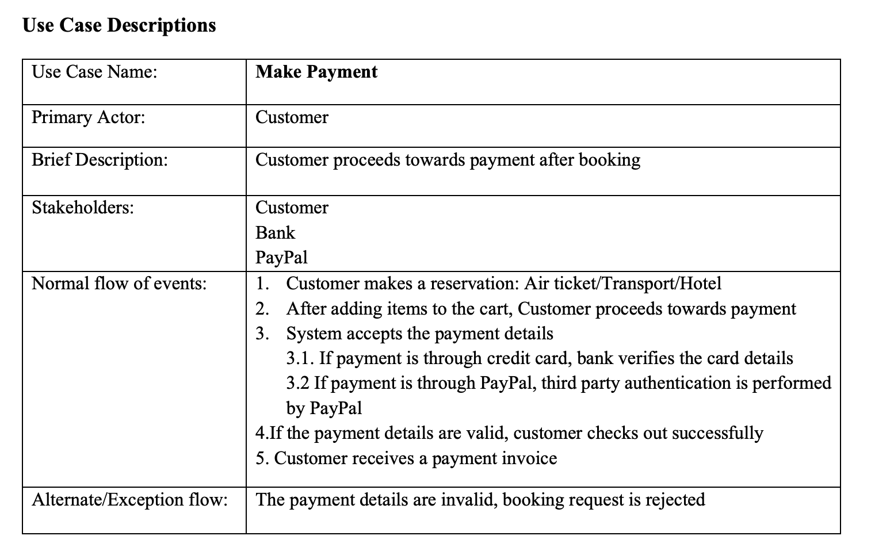

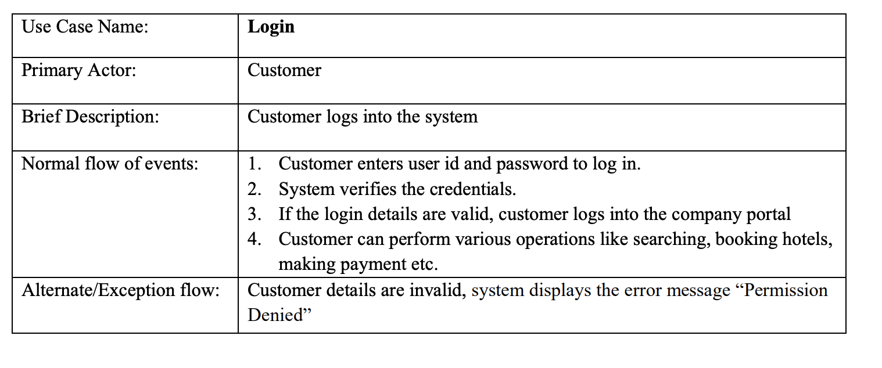

Solution 3:

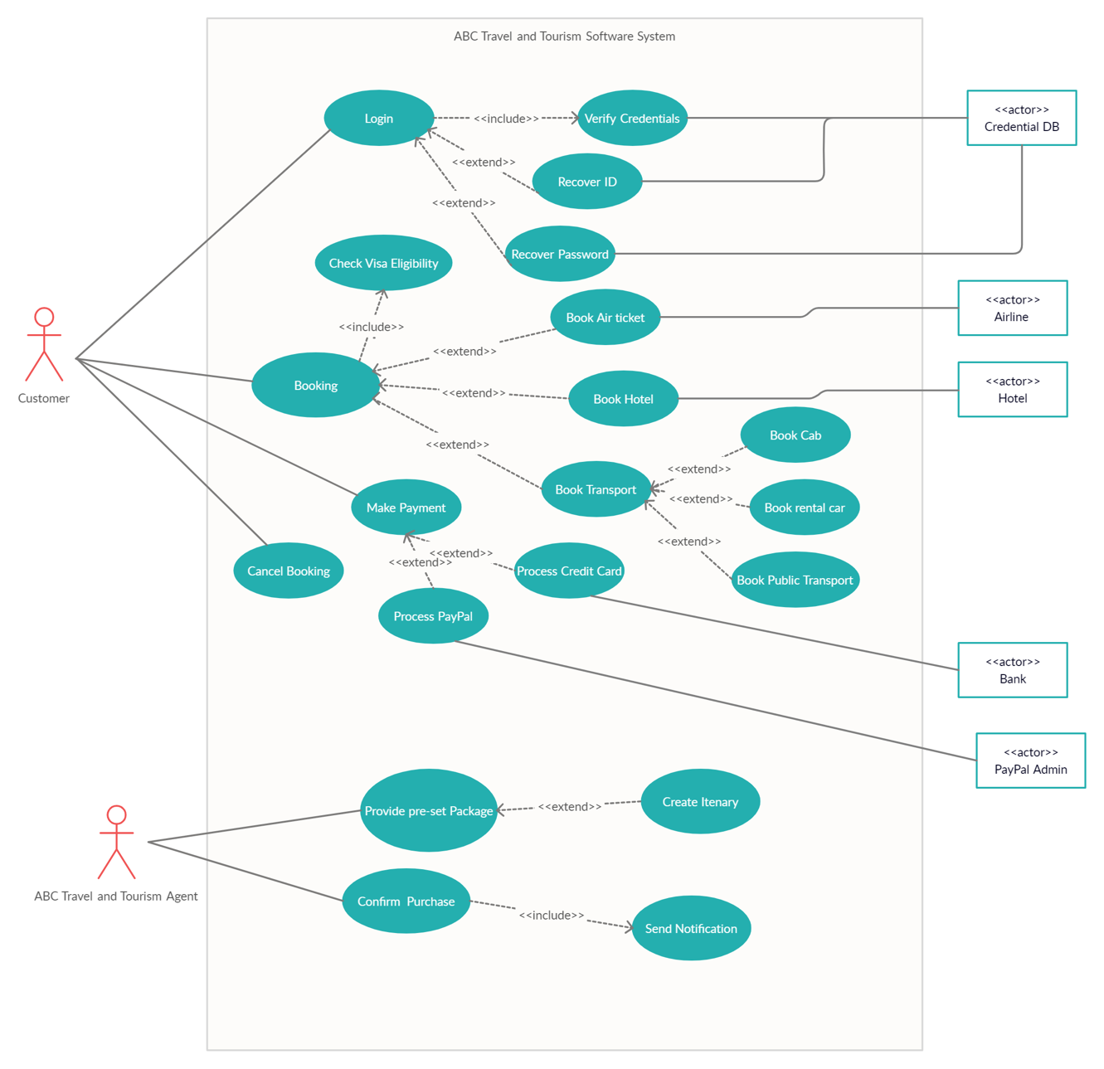

Solution 4:

